SCHOOL COUNCIL
Date: | March 6, 2023
Meeting Start Time: | 6:30pm
Meeting End Time: | 7.43 pm
Members in Attendance: | Judi L, Jean Marc, Muneezah J, Kelly S, Diana, Sarah W, Sonica V, Sanjay S, John Y, Sanjay, Diana, Kalsum, Sana, Maninder, Alaa, Diana,  Betty Zhang,
Members Absent: | Kiran, Liat, Candice, Maninder
- Land Acknowledgement | - Jean Marc made land acknowledgement.
- Approval of meeting minutes | - Meeting minutes were approved
- School Administration Report /Judi & Jean Marc | - School Movie Night  - Judi shared ideas of what some other school councils had done.  - One school rented a private movie theater to do a family movie night  - Another school did a family bowling night.  - So renting a place for a movie night is being considered. Kids can sit in comfortable chairs and there will be no clean up afterwards.  - Barbecue/Open House  - School admin decided to do a barbecue/open house next year  - It will be kept small based on feedback received.  - Teachers will be around but it will not be a curriculum night.  - Judi/Admin made an executive decision and booked a place to do the barbecue on the Thursday before Thanksgiving.  - Community building Post Pandemic (I Think Challenge)  - Food Drive  - Grade 7 and 8 explored several ideas for community building  - Doing a food drive was chosen as the preferred activity  - Student leadership teams did a great job organizing it.  - Food drive items were donated to “Fair Share Food Bank” and “Halton Food for thought.”  - Great experience and leadership by Forest Trail students collecting, counting, categorizing, and organizing the donated items.  - Carnaval Des Coyotes/ Outdoor Play Day  - Lots of older and former students came to volunteer for the carnival and outdoor play day during the week of February 13-16.  - The school community really enjoyed guessing who is inside bon homme. Contrary to popular belief it was not Madame Brodner or Madame Dean, but Mr. Williams.  - March Madness  - French music throughout the month of March where students will be voting. So far we have completed picking winners for two brackets.  - Library updates  - Lots of development in the library and in the council will be able to see the changes during the next in-person meeting on May 8. The library is transitioning to more of a “School Community Hub.”  - School traffic/Physical activity :  - Judi approached by someone from the city and board to do a quick count/preliminary research to see if any schools could be enrolled in a pilot program promoting physical activity. A small team came to observe the traffic on Pine Glen road in the morning. They counted over 110 cars that entered the school parking lot not including the cars dropping kids outside the parking. They noticed that most of these cars were dropping the younger kids from JK to grade 2. There were only 28 older kids who walked to school.  - This was quite shocking to learn and school admin will work with student leadership team to better understand where kids are coming from, if there is seasonal variation for students/parents opting for cars, and to find ways to encourage physical activity by promoting “Walk, Wheel or ride to School on Wednesdays.”  - Judi requested the council to help promote physical activity too.
- Teacher’s Report
- Fundraising
- Pizza/Subway/ Sanjay | - Pizza and Subway programs going really well. Current term will end on March 10 and second term will start on March 24, 2023. Parents had the option of paying for the full term.  - Cookies will be offered for a dollar each.
- Suggestions/ Discussions | - Sana conveyed Liat’s request to council to spend some time visiting the school website and make suggestions of what they would like to see changed or updated. Members can email Liat directly as well with suggestions/feedback.
- Safety and Wellbeing by  Sara | - Sara updated that the school has been approved for 500 CAD.  - The Parent Involvement Commmittee Conference is going to be held on the 29th of April. The theme this year is “Nurturing the Whole Child: Mind, Body and Spirit.” Dr. Jean Clinton will be the keynote speaker. There will be free babysitting provided.  - Wellness Event May 11:  There will be a speaker and yoga session by an experienced instructor from Glen Abbey Community Center. The exact topic has not been decided yet.  - Sara provided updates from PIC meetings and what other schools are doing. Some of the activities/ideas in circulation include  - Raising awareness about food insecurity and helping parents plan health meals.  - Using UN’s Sustainable Development Goals (SDGs) as a guide to plan school projects/community events.  - Starting a school/community garden.  - Campaigns to raise awareness about reducing waste.
- Wish list /Technology discussion | - Judi suggested that moving forward the school will take care of the teachers’ wish list and allocate funds raised for technology as Chromebooks is going to be an ongoing expense.  - Judi to discuss with admin/tech team to come up with an estimate of how many Chromebooks will be needed each year.  - Jean Marc informed that IT service is working to have the passwords updated for all levels starting at the senior level.
- Budget Report by Rashed | - Please see the image for a snapshot.  - 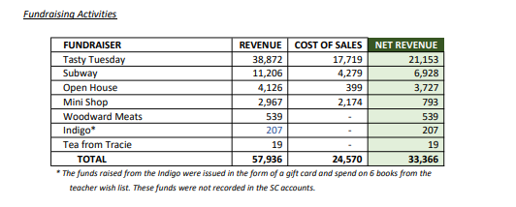  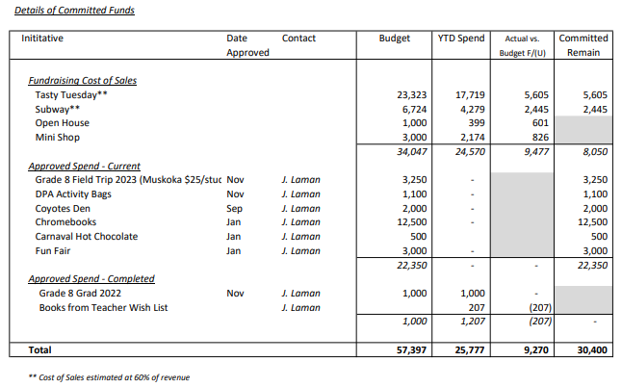
- New/old business | - MiniShop Feedback: Candice not available to share feedback. This will be discussed in the May meeting.  - Funfair: is scheduled for June 1st 2023 with June 8 as the rain date. Volunteers interested should reach out to Sana, Candice, or Diana. There will be a separate organizing committee. Please let Sana/Candice know of any tested/favourite food truck vendors for June 1st.  - Cross Guard: Sana F conveyed Liat’s comment/concern about the need for a Cross guard for the school. Judi said that the last time this was discussed, the school did not meet the minimum threshold traffic for cross guards. To be discussed in the May meeting.
- Next meeting | - May 8, 2023 6:30 pm (In person)  - Judi said Sanjay is bringing drinks

